LAB 5(1)
Aim: To design the logic circuit required to select the mode of ejector seats in aeroplane, modeling the orientation, air pressure and mode selector.
Components Used:
- Input
- NOR gate
- NOT gates
- AND gate
- 3 Digital LEDs
- Connecting wires

Link of Circuitverse: https://circuitverse.org/simulator/edit/ejector-seat-c68472a1-9da8-480c-ae89-1ff5cd0ddea7
Circuit Diagram:
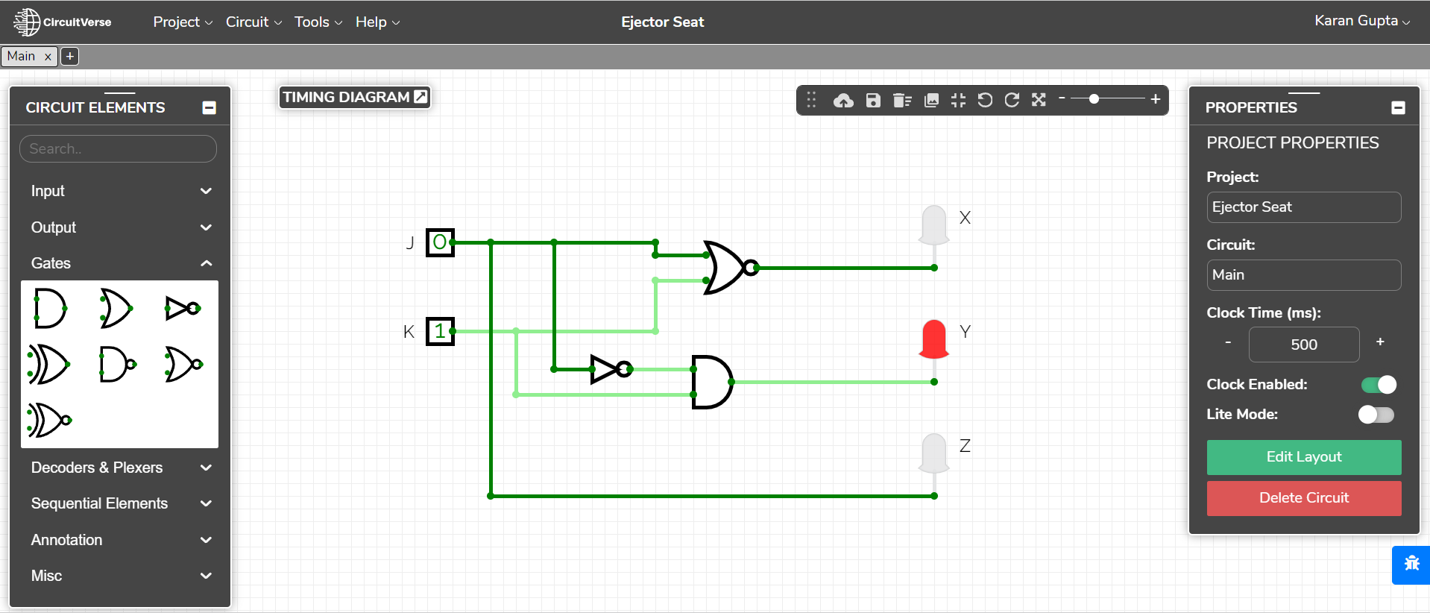
Truth Table:
J | K | X | Y | Z
0 | 0 | 1 | 0 | 0
0 | 1 | 0 | 1 | 0
1 | 0 | 0 | 0 | 1
1 | 1 | 0 | 0 | 1

Boolean Expression: X=J’.K’= (J+K)’
Y=J’.K
Z=J.K’+J.K= J.(K’+K) = J

Observation:
Mode X is on when aircraft is upright(J=0) and air pressure is high(K=0)
Mode Y is on when aircraft is upright(J=0) and air pressure is low(K=1)
Mode Z is on when aircraft is upside down(J=1) regardless of the air pressure
Result:The ejector seats with 3 modes were designed using gates.

LAB 5(2)
Aim: To design the logic circuit for a congestion detection system, modeling the
sensors and logging device
Components Used:
- Inputs
- 3 AND gates
- Connecting wires
- LED
Link of Circuitverse: https://circuitverse.org/simulator/edit/lab-5-b-f1f2655f-8a17-447b-bf4e-2dff5af3301c
Circuit Diagram:
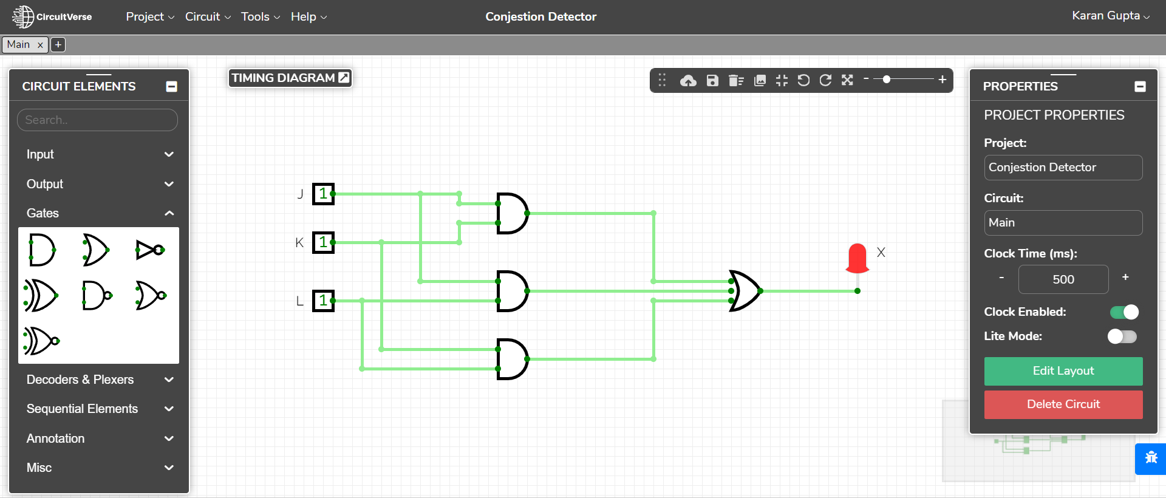
Truth Table:
J | K | L | X
0 | 0 | 0 | 0
0 | 0 | 1 | 0
0 | 1 | 0 | 0
0 | 1 | 1 | 1
1 | 0 | 0 | 0
1 | 0 | 1 | 1
1 | 1 | 0 | 1
1 | 1 | 1 | 1

Boolean Expression: X= J.K+K.L+J.L+J.K.L= J.K+K.L+J.L(1+K)= J.K+K.L+J.L
Observation:
The logging device(X=1) is activated when at least 2 of the sensors(J,K,L) are High.
Result: The congestion detection system was designed using gates.

